
National College of Computer Studies
Paknajol, Kathmandu

Report on
Motion Capture Technology

Submitted by: Submitted to:
Ayush Tuladhar Dadhi Ram Ghimire
Programme: Bsc. CSIT 1st Semester TU Lecturer
Roll. No: 7
Email: ayushtuladhar007@gmail.com

Abstract
Motion capture technology has transformed industries from entertainment to healthcare, allowing the development of lifelike digital figures and providing essential insights into human movement. This study provides a comprehensive overview of motion capture (mocap) technology, following its development from early photographic techniques to contemporary markerless systems. It delves into the principles, methodology, and applications of mocap in a variety of domains, including animation, biomechanical analysis, virtual reality, and sports science. The report also investigates contemporary improvements such as real-time tracking, machine learning algorithms, and interaction with other technology. This research illustrates the transformational influence of motion capture and its continuous relevance in influencing the future of digital animation and motion analysis, using a combination of historical analysis, technological exploration, and case studies.

Table of Contents

1. Introduction/Background 1
1.1. Evolution of Motion Capture 1
2. Methods and Systems 3
A. Optical Systems 3
B. Non-optical Systems 6
3. Applications of Motion Capture 9
A. Video Games 9
B. Robotics 10
C. Movement Capture 10
D. Movies 11
4. Advantages 12
5. Disadvantages 13
6. Motion Capture in the Future 14
Conclusion 15
References 16

1. Introduction/Background
Motion capture, often known as mocap, is a technology that records motions of objects or people digitally. It's frequently utilized to provide realistic movement in animation, video games, and motion pictures. Cameras and sensors monitor the movement of particular body parts or objects, recording their positions in space as time passes. Digital figures or objects are then animated using this data to move in a realistic way.
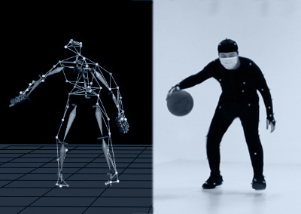
  - Fig: Motion Capture

1.1. Evolution of Motion Capture
Motion capture (mocap) technology has a long history, weaved across millennia by contributions from many fields. Motion capture techniques would thereafter be informed by the core notions for spatial measuring by Johann Heinrich Lambert's "spatial resection" invention in 1774. Motion capture's visual data collecting methods were made possible by the photographic techniques developed throughout the 19th century by pioneers such as Arago and Laussedat. Modern motion capture techniques owe much to Etienne-Jules Marey's work in the late 1800s, which included the development of the chronophotographic gun, which made it possible to collect sequential photos for the purpose of studying motion.
Motion capture technology advanced quickly in the 20th century, propelled by developments in computing, photography, and cinematography. Motion analysis and animation owe a great deal to the pioneering work of Max Fleischer (1915) and Gruber (1924), who developed projective equations. Researchers like Fenn & Morrison, who used high-speed film and marker systems to measure motion, and Aidman and Sigmark, who invented strobe lighted reflectors for motion analysis in auto accidents, made groundbreaking contributions in the middle of the 20th century. The entertainment sector also had a significant impact. In the 1960s, Disney Imagineering used mechanical motion programming for audio animatronics, and in the same decade, Bill Polhemus of Harvard University invented magnetic trackers.
Motion capture was widely used in several sectors during a period of rapid technology innovation in the late 20th and early 21st centuries. Leading companies that pioneered marker-based optical systems for real-time motion capture in animation and biomechanical study were Motion study and Vicon. Advancements such as markerless facial capture, active marker systems, and passive optical systems increased the potential of mocap and transformed a variety of fields, from video games and movies to sports science and medicine.
'Don't Touch Me' (Kleizer Walzac, Motion Analysis), the first computer-generated imagery film using passive optical motion capture, was produced in 1989. Other significant milestones include the use of motion capture (mocap) in revolutionary motion pictures such as "Final Fantasy: The Spirits Within" (2001) and "Avatar" (2009). ^{[1]} As hardware and software continue to progress and applications in domains like robotics and virtual reality grow, motion capture technology's future holds potential for significant innovation and influence.
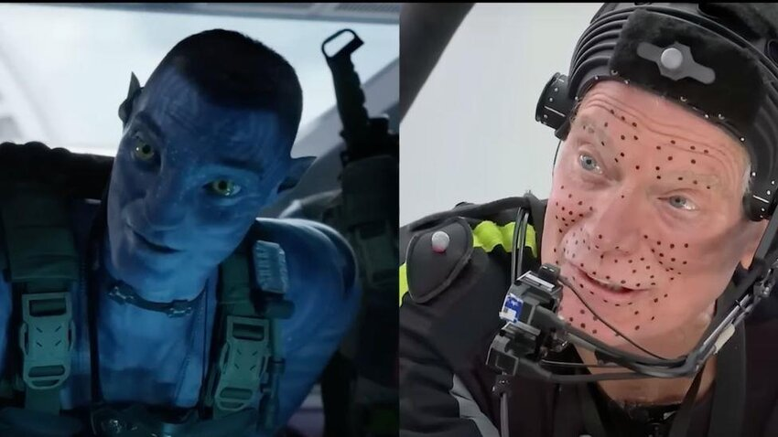
1.2 Fig: Avatar (2009) - Motion Capture

2. Methods and Systems
As technology advanced, motion tracking, also known as motion capture, found its way into the fields of sports, education, training, and, more recently, computer animation for movies, television, and video games. It began life as a photogrammetric analysis tool in biomechanics research in the 1970s and 1980s. Since the 20th century, the performer has had to wear markers close to each joint so that the locations or angles between the markers can be used to determine the motion. At least twice the desired motion's frequency rate is optimally tracked using acoustic, inertial, LED, magnetic, reflective, or combinations of these markers. Motion blur and low resolution are nearly identical in their difficulties, hence the system's resolution matters in both spatial and temporal domains. New ways have been developed since the beginning of the twenty-first century, in response to the rapid advancement of technology. Most current systems can extract the performer's silhouette from the background. Afterward, all joint angles are determined by fitting a mathematical model into the profile. For movements that do not show a change in the silhouette, hybrid systems are available that can accomplish both (marker and silhouette), but with less marker.

A. Optical Systems
Optical systems use data from image sensors to triangulate a subject's 3D position between two or more cameras calibrated to provide overlapping projections. Data acquisition has historically been accomplished using special markers affixed to an actor; however, more contemporary systems can gather reliable data by tracking surface features that are dynamically selected for each individual subject. Adding multiple cameras allows you to track a large number of performers or broaden the capturing area. These systems generate data with three degrees of freedom for each marker, and rotational information must be inferred from the relative orientation of three or more markers, such as shoulder, elbow, and wrist markers, which provide the elbow angle. Newer hybrid systems use inertial and optical sensors to reduce occlusion, boost user capacity, and improve tracking without the need for manual data cleaning.

- Passive marker
Passive optical systems employ markers covered with a retroreflective substance to reflect light generated near the camera lens. The camera's threshold can be set such that only bright reflective markers are sampled, ignoring skin and cloth.
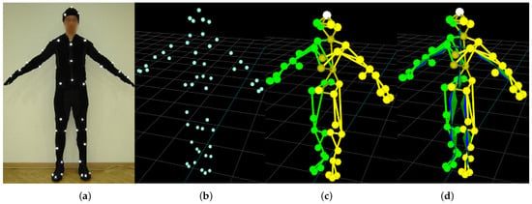
2.1 Fig: Passive optical syste,
Vendors use constraint software to reduce the problem of marker swapping, as all passive markers appear identical. Passive systems, as opposed to active marker and magnetic systems, do not require the user to wear cables or electronic equipment. [2] Instead, hundreds of rubber balls are affixed with reflective tape that must be updated on a regular basis. Markers are typically affixed directly to the skin (as in biomechanics) or velcroed to a performer wearing a full-body spandex/lycra costume created expressly for motion capture. This type of system can capture a huge number of markers at frame rates ranging from 120 to 160 fps, but by decreasing the resolution and tracking a narrower region of interest, it can track at speeds of up to 10,000 fps.

- Active marker
Active optical systems triangulate positions by rapidly flashing one or more LEDs and using software to discern their relative positions, similar to celestial navigation. Instead of reflecting externally generated light, the markers are driven to create their own. Because the inverse square law produces one-quarter the power at twice the distance, it can be used to expand capture distances and volumes. This also allows for a high signal-to-noise ratio, which results in extremely minimal marker jitter and great measurement resolution (typically down to 0.1 mm inside the calibrated volume).
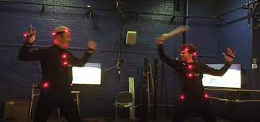
  - Fig: Active optical system

- Markerless
ESC entertainment, a subsidiary of Warner Brothers Pictures created specially to enable virtual cinematography, including photorealistic digital look-alikes for filming The Matrix Reloaded and The Matrix Revolutions movies, used a technique called Universal Capture that utilized 7 camera setup and the tracking the optical flow of all pixels over all the 2-D planes of the cameras for motion, gesture and facial expression capture leading to photorealistic results. ESC Entertainment, a Warner Brothers Pictures subsidiary created specifically to enable virtual cinematography, including photorealistic digital look-alikes for filming The Matrix Reloaded and The Matrix Revolutions films, used a technique known as Universal Capture, which used a 7-camera setup and tracked the optical flow of all pixels over all of the cameras' 2-D planes to capture motion, gesture, and facial expressions, resulting in photorealistic results.

B. Non-optical Systems
- Inertial system
Inertial motion capture ^{[3]} technology relies on small inertial sensors, biomechanical models, and sensor fusion algorithms. The motion data from the inertial sensors (inertial navigation system) is frequently wirelessly communicated to a computer, where it is stored or displayed. To measure rotational rates, most inertial systems use inertial measurement units (IMUs) that include a gyroscope, magnetometer, and accelerometer. These rotations are converted into a skeleton in the software.
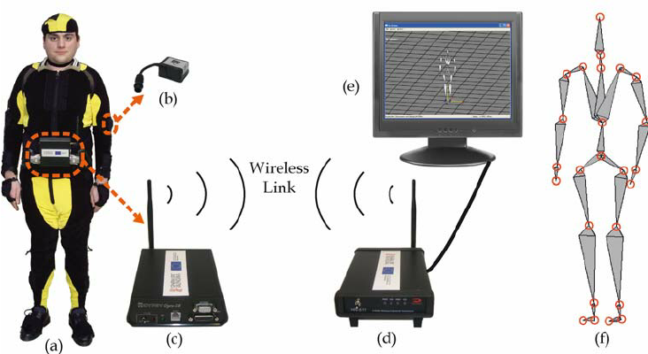
  - Fig: Inertial non-optical system
Inertial systems have the following advantages: they can capture in a range of situations, including confined places, they require no solution, they are portable, and they have huge capture areas. Disadvantages include decreased positional precision and drift, which can accumulate over time. These devices are comparable to Wii controllers, but are more sensitive, have higher resolution, and update faster. They can measure the direction to the ground to within one degree. Inertial systems are becoming increasingly popular among game developers ^{[4]}, owing to their quick and easy setup, which results in a fast pipeline.

- Mechanical motion
Mechanical motion capture systems directly track body joint angles and are also known as exoskeleton motion capture systems due to the manner the sensors are mounted to the body. A performer attaches the skeletal-like contraption to their body, and as they move, the articulated mechanical parts follow, measuring the performer's relative motion. Mechanical motion capture systems are real-time, inexpensive, occlusion-free, wireless (untethered), and offer an unlimited capture volume. Typically, they are stiff constructs composed of jointed, straight metal or plastic rods linked together by potentiometers that articulate at the body's joints.
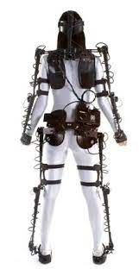
  - Fig: Mechanical non-optical system

- Stretch sensors
Stretch sensors are flexible parallel plate capacitors that monitor stretch, bend, shear, or pressure. They are commonly made of silicone. When the sensor stretches or squeezes, the capacitance value changes. This information can be provided by Bluetooth or direct input and used to identify small changes in body motion. Stretch sensors are resistant to magnetic interference and blockage. The sensors' flexible nature also prevents location drift, which is prevalent in inertial systems. Stretchable sensors, on the other hand, have a relatively low signal-to-noise ratio due to the material qualities of their substrates and conducting materials, necessitating filtering or machine learning before they can be used for motion capture. In comparison to other sensors, these solutions have a higher latency.
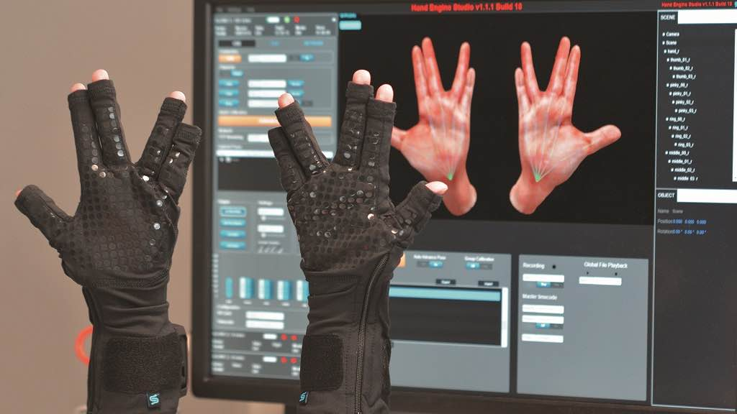
  - Fig: Stretch non-optical system

- Magnetic systems
Magnetic motion capture systems use the relative magnetic flux of three orthogonal coils on both the transmitter and receiver to calculate position and orientation. This enables tracking volume mapping and produces 6 degrees of freedom (6DOF) sensor output, using fewer markers than optical systems. However, they are subject to interference from metal objects and electrical sources in the surroundings, which can influence the magnetic field and sensor response. Magnetic systems provide real-time monitoring and distinguish between alternating-current (AC) and direct-current (DC) systems; nevertheless, they have smaller capture volumes than optical systems and are limited in severe performance movements due to wire constraints.
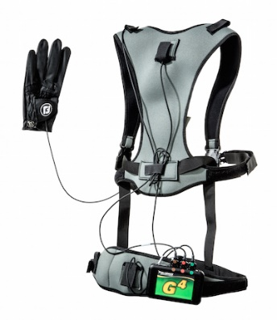
  - Fig: Magnetic non-optical system

3. Applications of Motion Capture
Some of the sample applications of motion capture are described below:

A. Video Games
Motion capture is commonly used in video games to create athletes, martial artists, and other characters. In 1988, an early type of motion capture was utilized to animate the 2D player characters of Martech's video game Vixen (played by model Corinne Russell) and Magical Company's 2D arcade fighting game Last Apostle Puppet Show (to animate digitized sprites). Motion capture was later widely employed to animate the 3D character models in the Sega Model arcade games Virtua Fighter (1993) and Virtua Fighter 2 (1994). Acclaim Entertainment, a developer and publisher, installed its own motion capture studio into its headquarters in mid-1995. Namco's 1995 arcade game Soul Edge used passive optical system markers for motion capture. Motion capture also uses athletes in based-off animated games, such as Naughty Dog's Crash Bandicoot, Insomniac Games' Spyro the Dragon, and Rare's Dinosaur Planet.
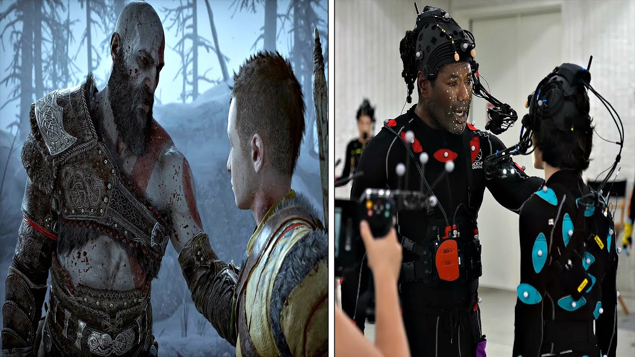
  - Fig: Motion capture in God of War Ragnorok

B. Robotics
Indoor placement is another use case for optical motion capture systems. Robotics researchers frequently employ motion capture systems to design and test control, estimation, and perception algorithms and hardware. Using the Global Navigation Satellite System (GNSS) in conjunction with Real-Time Kinematics (RTK) allows for centimeter-level accuracy in outdoor environments. However, this decreases dramatically when there is no line-of-sight to the satellites, such as in an interior situation. The majority of companies providing commercial optical motion capture systems give open source drivers that are compatible with the popular Robotic Operating System (ROS) framework, allowing researchers and developers to successfully test their robots during development.
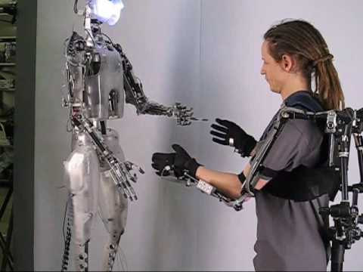
  - Fig: Motion capture in robotics

C. Movement Capture
Virtual and augmented reality companies, such as uSens and Gestigon, enable users to engage with digital material in real time by recording hand motions. This can be beneficial for training simulations, visual perception testing, and virtual walk-throughs in 3D settings. Motion capture technology is widely employed in digital puppetry systems to control computer-generated characters in real time.
Motion capture is used in clinical medicine for several purposes, including gait analysis. Techniques enable doctors to assess human motion across a variety of biomechanical parameters, frequently while streaming the data live into analysis tools.

D. Movies
Motion capture is used in movies for CGI effects, often replacing traditional cel animation, as well as for totally CGI creatures like Gollum, The Mummy, King Kong, Davy Jones from Pirates of the Caribbean, the Na'vi from Avatar, and Clu from Tron: Legacy. The Great Goblin, the three Stone-trolls, many of the orcs and goblins in the 2012 film The Hobbit: An Unexpected Journey, and Smaug were all made with motion capture.
The Lord of the Rings: The Two Towers was the first feature film to use real-time motion capture technology. This method displayed actor Andy Serkis' actions into the computer-generated imagery skin of Gollum / Smeagol as they were performed.
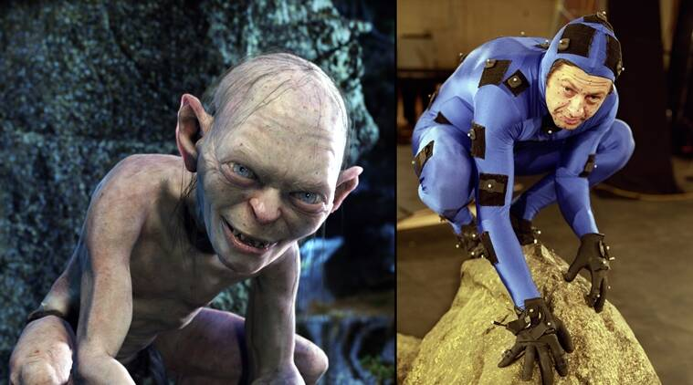
  - Fig: Motion capture in Lord of the Rings: The Two Towers

4. Advantages
Motion capture has various advantages over standard computer animation for a 3D model:
- Results can be obtained with low latency and near-real-time performance. In entertainment applications, this can lower the cost of keyframe-based animation. ^{[4]} The Hand Over technique is one example of this.
- The amount of effort does not vary in proportion to the intricacy or length of the performance as it does when traditional procedures are used. This allows for numerous testing with various styles or deliveries, resulting in a unique personality limited only by the actor's talent.
- Complex movement and realistic physical interactions, such as secondary motions, weight, and force exchange, can be accurately replicated. ^{[5]}
- In comparison to traditional animation approaches, the amount of animation data that can be created in a given period is enormous. This helps with both cost-effectiveness and achieving production deadlines. ^{[2]}
- Free software and third-party solutions can reduce costs.

5. Disadvantages
- Data collection and processing necessitate the use of specialized software and hardware.
- Small productions may find it difficult to afford the necessary software, equipment, and labor.
- Depending on the camera's field of vision or magnetic distortion, the capture system may have certain space requirements.
- When errors arise, it is easier to reshoot the scene than to attempt to modify the data. Only a few systems allow for real-time data viewing to determine whether a take should be redone.
- The initial results are limited to what can be done inside the capture volume without requiring additional data modification.
- Movement that violates the rules of physics cannot be captured.
- Traditional animation techniques, such as increased emphasis on anticipation and follow-through, secondary motion, or character shape manipulation, such as squash and stretch animation, must be incorporated later.
- Artifacts may emerge if the computer model's proportions differ from those of the captured subject. For example, if a cartoon character has enormous, oversized hands, they may collide with the character's body if the human actor is not careful with their bodily movements.

6. Motion Capture in the Future
One major trend in motion capture (mocap) technology is the incorporation of artificial intelligence (AI) and machine learning (ML) algorithms. These technologies have the potential to revolutionize mocap by improving motion tracking accuracy and efficiency, decreasing the need for human cleanup, and allowing for real-time performance analysis. AI and machine learning algorithms may learn from vast amounts of motion data to improve motion prediction, gesture recognition, and character animation, resulting in more realistic and lifelike digital performances. Furthermore, AI-powered mocap systems may allow adaptable and personalized motion capture experiences based on individual preferences and styles.
Another future direction in mocap is the creation of hybrid capture systems that incorporate various sensing modalities, such as optical, inertial, and magnetic technologies. By combining the characteristics of each modality, hybrid mocap systems can overcome occlusion, environmental interference, and tracking accuracy restrictions. These systems may provide increased flexibility and agility when recording motion in a variety of settings, including as outdoor situations, complex scenarios, and interactive applications. Furthermore, advances in sensor fusion techniques and synchronization approaches will enable the seamless integration of data from many sensors, resulting in more complete and robust motion capture solutions.
Furthermore, the growth of mocap applications beyond traditional sectors such as entertainment and biomechanics is an important trend. Healthcare, education, virtual reality, augmented reality, and human-computer interaction are among the industries that are rapidly using mocap technology for a variety of applications, including rehabilitation, training simulations, telepresence, and immersive experiences. Mocap's potential influence across multiple sectors will increase as it becomes more accessible and affordable, thanks to advances in hardware downsizing and software development. This trend toward democratization and diversification of mocap applications will spur innovation and open up new avenues for collaboration and multidisciplinary research.
As technology advances and user needs shift, mocap is positioned to play an increasingly important role in defining digital content creation, human-machine interaction, and immersive experiences in the coming years.

Conclusion
Motion capture technology has evolved into a flexible and indispensable tool with widespread applications in a variety of sectors. Mocap allows us to capture, analyze, and animate human movement with unprecedented realism and precision in a variety of applications, including entertainment and healthcare. As technology advances and the physical and digital worlds blend, motion capture remains at the vanguard of innovation, driving revolutionary change and opening up new avenues for creativity, research, and human expression. This paper demonstrates mocap's long-term significance and impact on how we perceive, interact with, and harness the power of motion.

References

[1] “Milestones in the development of motion capture” retrieved from:
http://www.motioncapturesociety.com/resources/industry-history

[2] "Motion Capture: Optical Systems” retrieved from:
Next Generation. Imagine Media

[3] "Full 6DOF Human Motion Tracking Using Miniature Inertial Sensors” retrieved from:
http://www.xsens.com/images/stories/PDF/MVN_white_paper.pdf

[4] "Xsens MVN Animate – Products" retrieved from:
Xsens 3D motion tracking

[5] "The Next Generation 1996 Lexicon A to Z: Motion Capture" retrieved from:
Next Generation. No. 15. Imagine Media.

